**Loops & Coils**

1. Draw the magnetic field around a loop of wire. Make sure to include:
   1. The direction of conventional current
   2. The direction of the magnetic field

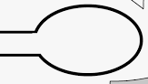

1. Draw the magnetic field around a Solenoid Coil. Make sure to include:
   1. The direction of conventional current
   2. The direction of the magnetic field
   3. The North and South Pole

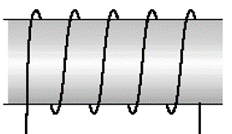

1. Explain how the magnetic field around a Solenoid Coil is similar to a bar magnet.
2. List some differences between the magnetic field around a Solenoid Coil and the field around a bar magnet.

1. List three factors that affect the magnetic field of a Solenoid.

**Right Hand Rule #2 (For Solenoids)**

1. Summarize the Right Hand Rule for Solenoids as follows:
   1. Your Fingers curl in the direction of:
   2. Your Thumb points in the direction of:

1. Draw a diagram showing how to use the right hand rule for Solenoids.
2. Complete each of the following two drawings as follows:
   1. Show the direction of conventional current around each coil
   2. Predict the location of the North and South Poles

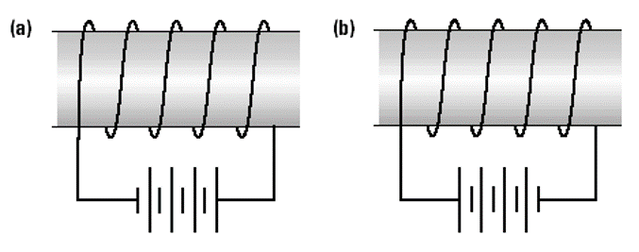

1. Explain if the two Solenoids in the diagram above will attract or repel.

**Induction**

1. Answer the following (True or False):
   1. An Electric Current (moving charges) creates a Magnetic Field:
   2. A *Changing* (dynamic) Magnetic Field creates an Electric Current:
   3. A *Uniform* (unchanging) Magnetic Field creates an Electric Current:
2. Summarize the Laws of Magnetic Induction Below:
   1. Faraday’s Law
   2. Lenz’s Law
3. Summarize how a current is induced in a solenoid for a magnet moving   
   *towards* the solenoid:
   1. The magnetic field…

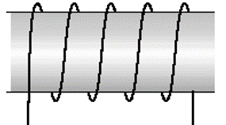

* 1. The current…

1. Summarize how a current is induced in a solenoid for a magnet moving   
   *away from* the solenoid:
   1. The magnetic field…



* 1. The current…

1. Summarize the four Key Points of Electromagnetic Induction:

**Questions**

